Questão 01

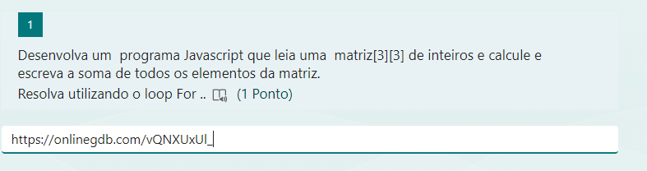

<https://onlinegdb.com/vQNXUxUl_>

Questão 02

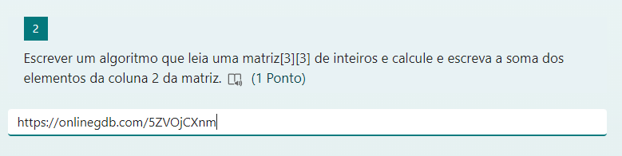

<https://onlinegdb.com/5ZVOjCXnm>

Questão 03

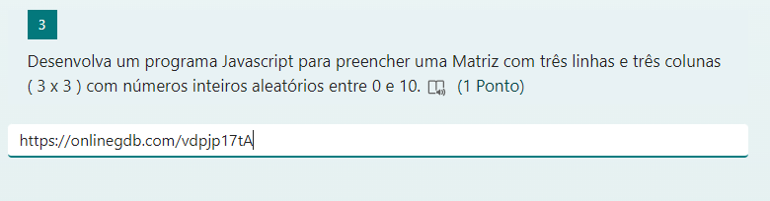

<https://onlinegdb.com/vdpjp17tA>

Questão 04

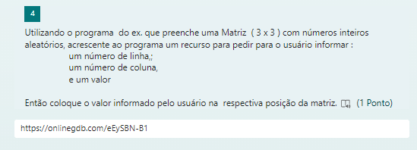

<https://onlinegdb.com/eEySBN-B1>

Questão 05

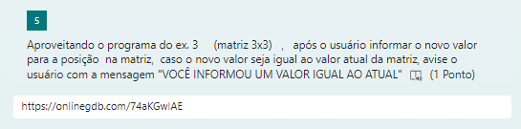

<https://onlinegdb.com/74aKGwlAE>

Questão 06